Instructions for The Final Paper (Research Proposal):
Due Nov. 30th at 11:59 pm
Final Paper Assignment Quantitative Methods Criminology

Instructions to follow: You may take its suggestions to start your proposal writing, especially you should consider to write up your Literature Review asap.

All written assignments require APA format (please see related information in the Resources). The Font should be 12 point Times New Roman, the 1-inch margin on all sides. The length of the major research proposal text (NOT including abstract, references, appendices) should range between 8 - 20 pages. The lengthier of your proposal is not necessarily make it a better proposal, but the more comprehensive of your concerned issues discussed in the paper, the proposal is considered a better-structured proposal.
____________________________________________________________________________________
Final Paper. (20 percent of final grade or 100/500 points). Your final project in this class will be to assemble a packet of materials for submission (as if you would submit it to the Institutional Review Board). This includes all required paperwork, consent forms, and most of all a research ‘protocol’ or description of your research design, the contribution you hope to make to social knowledge, and the protections for research with human subjects appropriate to your proposed project. During the final session of the semester, you will present your IRB proposal to the group. The final written version of this work is due at the last day of Topic 7. You are strongly recommended submitting a draft of your materials to another class participant for comments ahead of time so you can refine it before submitting to the class site. This is your opportunity to present your own proposal and demonstrate that you have met the appropriate learning goals. Your paper will go through Blackboard plagiarism examination and any main text (while references are normal since many others may cite same articles you cite in yours) found plagiarized content is subjected to penalty. Quotations are not welcomed in the final paper. Please rephrase and cite them instead.
Topic-related Suggestions for Final Paper (TSFP). In each Topic folder, there is Topic related ideas that could help you to work ahead on your final paper. The ideas include descriptions that could guide your final paper writing on the session that is related to the Topic, and guiding questions that help examine your developing research process ideas. For example, your final paper should include a session of your research sample subjects. The TSFP in the Topic Sampling folder will provide some questions and directions that you may consider developing your sampling plan for your final paper.
INSTRUCTIONS FOR PAPER:
Research Proposal Writing Direction(1).pdf

HELPFUL LINKS:

Choosing and Narrowing Research Topics for APA & MLA Essays:
https://youtu.be/jSHXb83Xtsk

Research paper resources/APA format in a sample paper.pdf

Research paper resources/Table of Content, Snapshots of Research (1).docx

Finding Articles in LU online database.pdf

Research paper resources/sample_apa_style_litreview.pdf

Sample IRB from (1).docx

Videos that might help understand the Research:
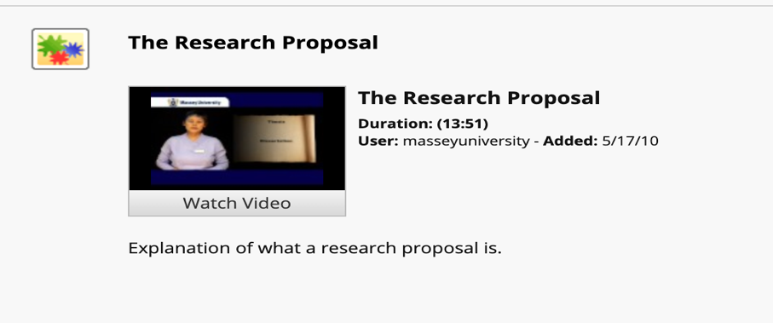https://youtu.be/zJ8Vfx4721M
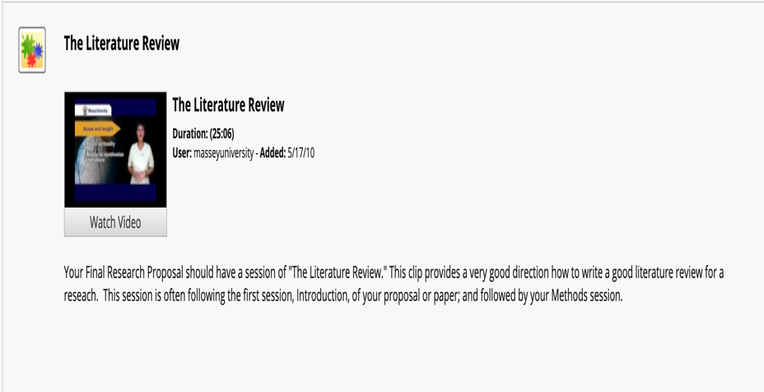https://youtu.be/jKL2pdRmwc4
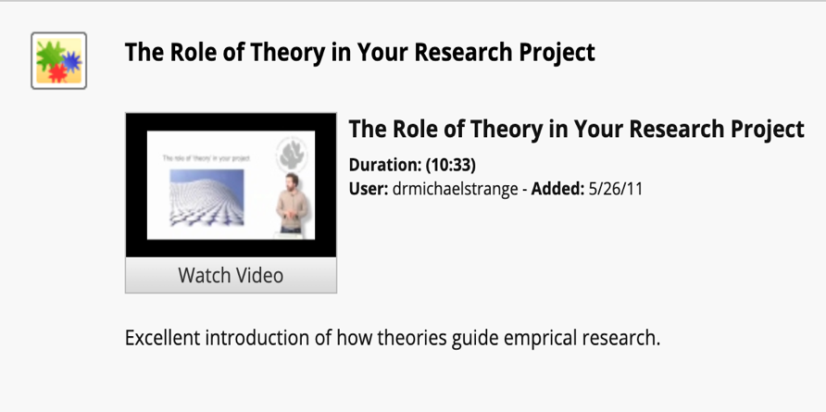https://youtu.be/0-t5Ug7Mcu4

Research Proposal Considerations:

Posted on: Tuesday, November 5, 2019 8:25:31 PM CST

Hello, Students! Here is some information that may assist you in writing up your Research Proposal. It is approved by the instructor.

Hopefully, the following details will assist you moving forward in your proposals. This is a process that will not be completed overnight. Please keep your spirits up, as you are not alone. We are here to assist you along the way.

You are writing up a research proposal (plan) to convince readers (your thesis advisor) how are you going to conduct a study. You will introduce the issue (why is this issue important and needs to be studied further), what the past research has done that were related to the issue and how they can help inform and guide the current interested topic. Then introduce your chosen research methods (many to choose from the textbooks) and your justification of the choice. What results you are looking for and what are potential challenges to have the study completed (challenges and solution in every step)? Of course, if you find a scholarly journal publication, it show these components plus the results (your proposal has NO results since the study has not started yet. You may foresee the possible results according to your literature review). How long will the proposal be? It (main text only) can range from 8 to 20 pages, depending how thoughtful your research proposal intends to reach and the size of your chosen topic). The longer is NOT the better. A good proposal should exhaustively consider all important variables and practical, with comprehensive literature review (showing your sufficient knowledge on the topic).

The first thing you should think of is your research questions. What questions do you intend to answer from your research (results)? For example, if you want to know why some victims of domestic violence stay as returning clients to family protection services. You may study the causes of why they stay in an abusive relationship and why cannot they leave. Their family environments, relationships, available social networks, may all need to be collected as parts of your data. Do not think about if you are capable of conducting the study because this is just a proposal assignment. What you need to think about is how to design a research project that can be done and the results the study will receive are correct and able to answer your research questions. Almost all the research journal papers are a study, and they can be models of your research, except they completed their study and have research results, while yours is a proposal, there will be no results presented but some expected results (could be predicted according to your literature reviews which include the past studies and their findings in the related issues may help you infer your research findings.)

Avoid topics on a particular criminal case but the similar crime type is fine. The literature is free of your choices but should be academic based such as scholarly journal publications and books, while governmental reports are considered a good sources for the literature too. Additional common topics may include “causes of domestic violence”, “The relationship between early childhood attachment and being a delinquent,” etc.

The research review asks you to read a research journal paper and then answer a list of questions I provide regarding the adopted methods in the study. You will evaluate the quality of the research design of the research. This probably takes you a day to complete. So, there is no need to worry about it now. The research paper takes a long time to complete. You should review many journal papers to confirm your ideas, and there are lots of decisions to make while deciding research design details. After those two, writing will be another challenging job. These tasks will make you busy enough. It is a better idea to worry about the Research Review later.

As far as data, you will not analyze the data yet but formulate what variables you are going to include in your research and explain how the data you know could provide such variables for your research analysis. Again, you should first think of the research questions you intend to answer from your research results (if the project is carried out). Additional examples of research questions may be something like "why drug offenses more in certain zip codes than others?" "What social-economic backgrounds suggest a greater commitment to drug offenses?" "What life incidents are more frequently observed in drug users (or dealers)?" After you are sure what research questions you are going to respond to, you should know what variables will be included in your research and if your data can provide these variables. At the same time, you should review some literature conducted in the area of drug offenses (which may inspire your consideration of certain research questions).

Please email me or I if you need assistance, as we are here to help guide you through this course.

You can do this!

